1. 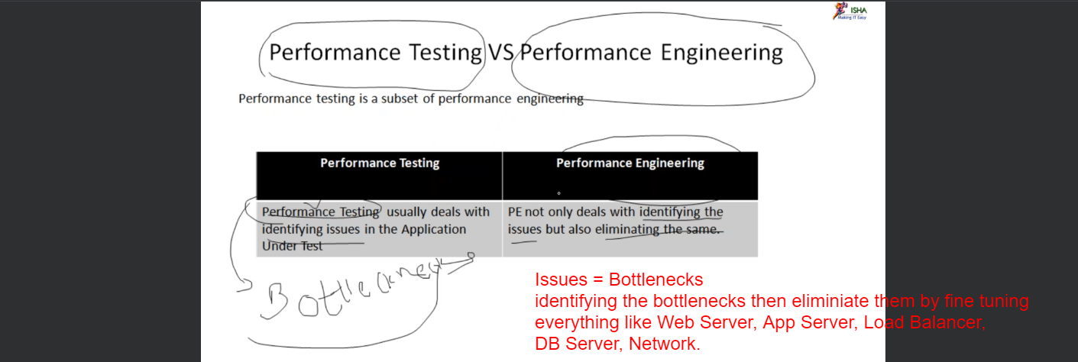  
   Performance Engineer has more work than that of Performance Tester.
2. 